Order Of Service

Singing: Psalm 67—CW page 91

Reading: Psalm 123

Opening Hymn: CW 375

Reading: I John 1

Request Hymn: CW Supplement 702

Reading: Luke 14:15-24

Sermon Hymn: CW 363

Sermon Text: I Samuel 16 - 17

David’s Youth

Prayer

The Apostles’ Creed, TLH page 12

Holy Communion

The Lord's Prayer

The Blessing

Closing Hymn: CW 169

************

Koinonia Hour
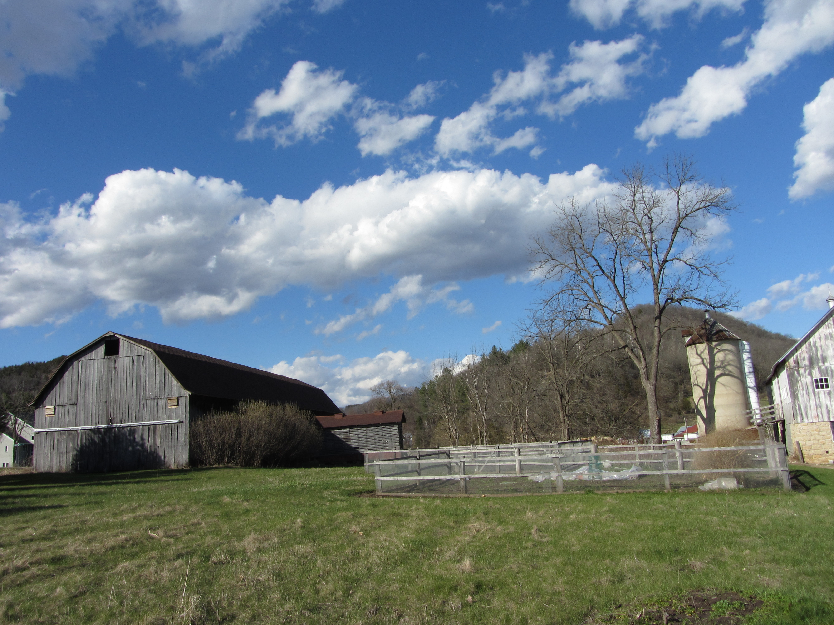

Summer In The Valley

Water
Of
Life

7 September 2025

W A T E R O F L I F E

Independent Christian Church—Conservative Lutheran Doctrine

Worship Service: 9:30 a.m.

Larry Cooper, Pastor E-Mail address:
lcooper@wateroflife.cc
Web Site:
www.wateroflife.cc

* * * * * * * * * * * * * * * * * * * * * * * * * * *

Sermon Text: I Samuel 16 & 17

David’s Youth

* * * * * * * * * * * * * * * * * * * * * * * * * * *

